Participant Information Sheet for Community Advisory Board
Project: SMAARTS: Social media, autism & ADHD, and the route to self-diagnosis (Phase 1: community advisory board)
Introduction
My name is Ruth Leiser (she/her). I’m a PhD student at the University of Strathclyde. You can email me at: ruth.leiser@strath.ac.uk. Please note that there is a lot of information included in this sheet, and if you would prefer to have a one-to-one conversation where I can explain the research and your potential role, please get in touch with me to arrange this. An audio version of this information sheet is also available at the bottom of this document, and it is also hosted on the study website: www.smaartsproject.com if a web format would suit you better.
What is the purpose of this community advisory board?
My PhD project is aiming to better understand the process that people go through when they self-diagnose as neurodivergent based on content they’ve seen online. The term ‘neurodivergence’ is very wide-ranging, but of particular interest to me in this project are autism, ADHD, and ‘AuDHD’. AuDHD is a term that has been created by people to describe the experience of being both autistic and ADHD. In the last few years there has been a lot of mainstream media coverage and changes in public opinion around self-diagnosis, and this has led to this process being seen as controversial by some – many people view it as a bad thing, but this does not accurately represent the full picture. Research into the topic is lacking, and this project aims to provide additional perspectives.
Involving members of the community is important to me within this research project, because a lot of research has been conducted ‘about’ or ‘on’ people, rather than ‘with’ them. As a result, a lot of people – especially from marginalised groups – don’t feel like they can trust research & researchers, and don’t feel represented by the work that is published about experiences similar to theirs. In order to try and make research more fair, more useful, and do less harm, it’s important to involve people from the group(s) that are being investigated in the research process. This is what I’m doing in my project. Within our research team, there is both an understanding of, and lived experience of, neurodivergence, however this does not represent everyone within the community. Therefore, I am recruiting a number of neurodivergent people to form what is known as a ‘community advisory board’ (I’ll refer to it as the ‘CAB’ from now on).
My project has 2 phases. Phase 1 is the work I’m hoping to do with you – discussing the project, planning it out, creating the materials and adapting the interview format for Phase 2. Phase 2 will involve me interviewing roughly 10 self-diagnosed neurodivergent people. Phase 2 will take place after we have done our initial work as part of the CAB, and will involve recruiting a different group of people. You will not be interviewed for Phase 2. The CAB’s role is to shape Phase 2, to achieve three key things:
- To provide feedback and input in order to make sure the research is being carried out in the best possible way. Part of this is helping to prevent any harm being done to potential participants, by checking through the different parts of the research process. For example: are the information sheets for participants accessible? You might pick up on language (phrases, words etc) included within the documents, that people wouldn’t understand, would be confused by, or would find offensive/upsetting. You’ll also be told what the interviews in Phase 2 will be like for participants, and will be invited to provide feedback/suggestions on how to make the experience better or include an accommodation that we hadn’t considered.
- To have a say in how the results of the research are then communicated to people. This could mean making suggestions about who needs to know the results, how to reach these people (for example, via social media, neurodivergence organisations, or a particular website etc), and how best to actually tell people about the things we find out (e.g. in-person, online, through images, through short-form video etc).
- To make suggestions about what is still to be explored within this research area, and what future research should be focusing on. This will be included within the findings of this project.
Do you have to take part?
There is no requirement to join the CAB. It is your decision whether you would like to form part of the community advisory board. You can also choose to join, and then change your mind. You will not be forced to continue participating, and there will be no negative consequences if you choose to end your involvement.
What will you do in the project?
In simple terms, your role in the project would involve making suggestions, giving feedback, or raising concerns about Phase 2 of the project (the interviews). There are different possibilities for taking part.
Members of the CAB can choose whether they would prefer to take part in it via a group chat, or one to one communication with me. If you choose to take part in a group, this will take the form of meetings held on Zoom. There will be approximately 3 or 4 meetings. If you choose to take part on your own, we can either chat one-to-one via Zoom, or all communication can take place via email (or, if you would prefer a different form of communicating, like instant chat, we will try our best to accommodate this).
The different stages of the CAB’s involvement in the study are shown in the diagram below:
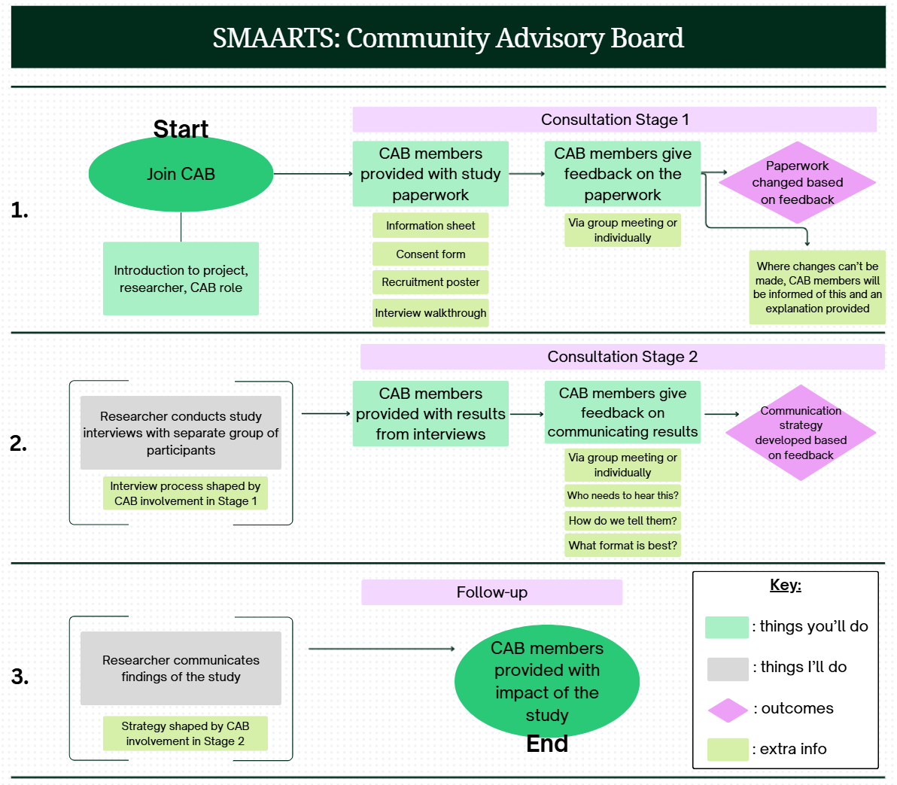
CAB members will be compensated for their time. Please get in touch if you would like further details about this. CAB members should be aware, however, that receipt of compensation for participation in this study may impact their government benefits, where applicable.
Why might you be suitable to take part?
We are looking for neurodivergent people who can potentially offer insight and opinion into the way I’m planning to do the research. Although neurodivergence can mean a lot of different things, and relates to a lot of different experiences, for this project we are only looking at autism, ADHD, or a combination of both. You can take part in the CAB if you also experience other types of neurodivergence in addition to autism and/or ADHD.
There is no requirement that you have been diagnosed as autistic or having ADHD by a doctor. However, if you are self-diagnosed, we would ask that you have been identifying as neurodivergent for quite a long time – 5 years or more. This is simply because it means that you will probably be more aware of – and able to advise on – potential accessibility issues and barriers to taking part in something like the research project. If you are someone who has only recently self-diagnosed, you might not be best suited to form part of the CAB, but you may be a perfect candidate for the interview portion of my research, and I would encourage you to get in touch with me about that instead. I will not ask for any proof of formal diagnosis or long-term self-diagnosis.
Other than being autistic and/or having ADHD, the only requirements are that you are 18 years old or above, and that you can communicate in English. Verbal communication is not a requirement, and the project can accommodate alternative communication (i.e., email chat), however, please be aware that I am not able to communicate in sign language or any written/spoken language other than English for the purposes of this project. If you would like to further discuss alternative communication, or the involvement of a communication supporter, please get in touch.
What are the potential risks to you in taking part?
There is very low risk involved in taking part. Being a member of the CAB will involve at least 3 different stages of input, and you should consider if you have capacity for this. You will be given sufficient time to respond to emails/give feedback, so it’s ok to take the process slowly and contribute only when you have capacity to do so. If you would prefer not to give feedback on a certain stage of the process – for example the consent forms, or the interview process, or the way in which we’ll communicate the results – that’s ok and you can still take part overall.
Whilst we will try our best to make sure that the CAB discussions are safe spaces, due to the nature of the topics and the potential for groupwork, it may be that we will touch upon sensitive topics during the course of our discussions.
What information is being collected in the project?
You will be invited to provide feedback on the planning for a future research study. I will show you different documents (for example, consent forms, information sheets), recruitment materials (for example, a poster advertising the study), and will walk you through the interview process. I’ll be looking for feedback to try and make the interview phase of the study (Phase 2) as coherent, unambiguous, and accessible as possible. An example of a suggestion might be: changing the wording of a sentence in the consent form. You might also suggest alternative ways of setting up the interview. No personal information other than the name you wish to be called by the researcher, and a way of contacting you – which are only for the purposes of communication, and are not included in the research data – will be collected about you during the course of the project.
The suggestions that you make, and the feedback that you give, will be put into a spreadsheet. I will then work out if I can make these adaptations or if that won’t be possible. I will feed back to the CAB members about which changes I was able to make, and if there are any that I can’t make I will explain why. All the information in the database will be anonymous and I’ll use a pseudonym for you, so your real name won’t be included next to your suggestion/feedback.
Who will have access to the information?
The only person with access to the emails we exchange, or the audio recordings of our group meetings will be me – Ruth – as lead researcher. Once I have collected your feedback and put it into an anonymised spreadsheet, this information can be shared with others, but I will remain the only person with access to your name or contact information.
If you choose to take part in a group meeting, which will be held on Zoom, it is important to note that confidentiality can’t be guaranteed because other members will see you, know your name etc.
Where will the information be stored and how long will it be kept for?
Recordings from groupwork sessions will be retained until the feedback from members has been logged, and then the file will be deleted. Data provided via email will be stored in an anonymised state on the researcher’s computer. Names and personal details will not be included. Anonymised data will be stored for 5 years after the completion of this study, in line with the University’s data policy.
Thank you for reading this information – please ask any questions if you are unsure about what is written here.
All personal data will be processed in accordance with data protection legislation. Please read our Privacy Notice for Research Participants which has been provided with this document pack for more information about your rights under the legislation.
What happens next?
If you would like to find out more information about the project, or would like to become a member of the community advisory board, please contact me at: ruth.leiser@strath.ac.uk to discuss further. More information – and downloadable copies of these documents – can be found on the study website at: www.smaartsproject.com
If you would like to take part, you will be asked to sign a form which will make clear the requirements of the role and what is being asked of you. There is no requirement to take part, and if you would like to opt out at this point, I’d like to thank you for your interest up to this point.
Name of department: Psychological Sciences & Health
Title of the study: SMAARTS: Social media, autism & ADHD, and the route to self-diagnosis (Phase 1: community advisory board)
Researcher contact details:
Ruth Leiser, Department of Psychological Sciences & Health, Room GH676, Graham Hills Building, 40 George Street, Glasgow, G1 1QE
Contact email: ruth.leiser@strath.ac.uk
Chief Investigator details:
Professor Paul Flowers, University of Strathclyde, School of Psychological Sciences & Health, Room GH6.76, Graham Hills Building, 40 George Street, Glasgow, G1 1QE
Contact email: paul.flowers@strath.ac.uk

This research was granted ethical approval by the University of Strathclyde’s Department of Psychological Sciences & Health Ethics Committee.
If you have any questions/concerns, during or after the research, or wish to contact an independent person to whom any questions may be directed or further information may be sought from, please contact:
Department of Psychological Sciences & Health Ethics Committee
University of Strathclyde
Graham Hills Building
40 George Street
Glasgow
G1 1QE
Telephone: 0141 548 3707
Email: ethics@strath.ac.uk
The audio version of this document can be found in the file below:


